**ASSIGNMENT – 2**

**1)Build a python code, Assume u get temperature and humidity values**

**(generated with random function to variable ) and write a condition to continuously detect alarm in case of high temperature**.

**CODE:**

import random import time

while (1):

temp = random.randint(0, 100) humidity = random.randint(0, 100) if temp>60: print("ALERT!!! temperature: "+str(temp)+"°C") time.sleep(1)

print("ALERT!!! humidity: "+str(humidity)+"%") time.sleep(1)

**Output:**

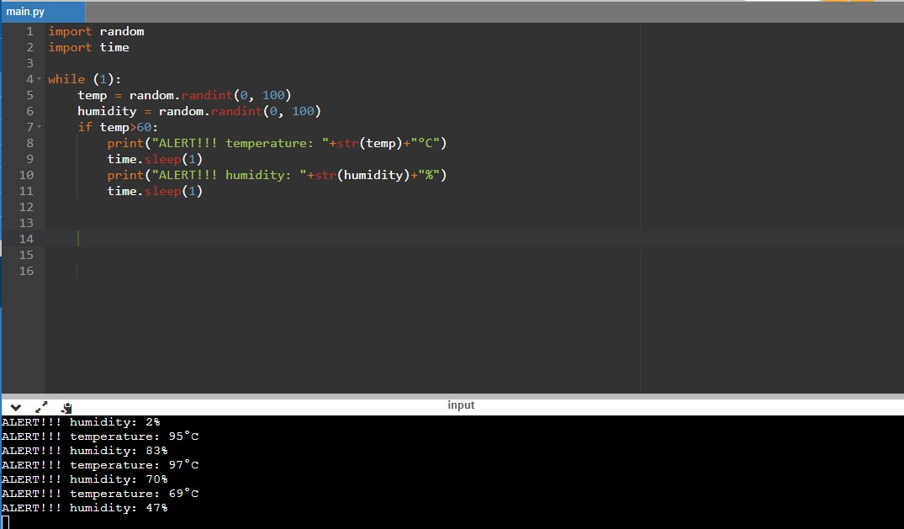

**NAME:M.Sabina**

**ROLL NO:953519205005**